MIS779 – Decision Analytics In Practice
Part D – Final Report (Group)
This report has been prepared by:

ANJELA PAUL WILLIAM (224080823)
AJIN FRANCIS ANTO (223725085)
MANISHA KUMARI (224092829)
RAHUL PAWAR (223329374)
SACHINI DILUKA EDIRISINGHE (224304752)
VIET PHUONG DANG (224383373)

Contents
EXECUTIVE SUMMARY 2
INTRODUCTION AND APPROACH 3
INTRODUCTION 3
APPROACH 3
ASSUMPTIONS 3
DATA ANALYSIS 4
DIAGNOSTIC ANALYSIS 5
INTERPRETATION 8
RECOMMENDATIONS 8
References (APA7) 10

EXECUTIVE SUMMARY

World Vision Australia is a non-profit organisation helping to reduce poverty, protect vulnerable children, and empower communities through long-term, sustainable change. The effectiveness of WVA, which its supporters generously fund, depends on quick and effective engagement with its supporters.

The Bounceback journey is a key supporter-engagement initiative within WVA’s fundraising strategy, aiming to re-engage inactive or lapsed supporters. However, a consistent journey applied to all donors, regardless of their behaviour, timing, or channel responsiveness, results in minimised value realisation, unnecessary delays, and additional costs. We conducted a diagnostic analysis to identify patterns and create more thoughtful, segmented journeys. Our analysis focuses on four problems about timing, channel performance, value distribution, and engagement degradation using data from the three main campaign types (Birthday, Christmas, and Education).

Key Findings:

(1) The timing of donations varies significantly each campaign: Education shows "early-or-never" behaviour, Christmas converts on a longer cycle (31–60 days with a longer tail), and Birthday converts the quickest (≤30 days).
(2) Channels operate at varying speeds: Email supports later-touch conversions, SMS peaks at Touch-2 as a reminder, and Direct Mail initiates most initial presents at Touch-1.
(3) Value varies across campaigns: Christmas generates the highest total, and the average values. Birthday revenue is stable, while education generates the least revenue.
(4) Engagement decay varies by family: a flat, lower-efficiency curve for education; significant early decreases for birthday and Christmas, indicating that a single sequence drives too many supporters into low-engagement stages.

In a sector where mass-donor pools are limited and value concentration is increasing, treating all supporters equally inflates cost-per-dollar-raised, wastes late touchpoints when propensity is low, and delays revenue from quick responders.

Recommendations:

- Optimise channel sequencing according to segment and campaign: Use email for nurturing, front-load direct mail or SMS for quick responders, and then lock in the supporter's responsive channel.
- Launch a Donor Value Segmentation Dashboard: This classifies supporters/campaigns by value (High/Medium/Low) and speed-to-donation, and recommends the optimal DM/SMS/Email sequence—reordering touches, not reducing them.

INTRODUCTION AND APPROACH

INTRODUCTION
World Vision Australia (WVA) is one of the country’s leading not-for-profit oprganisations, committed to improving the lives of vulnerable children and communities. A central part of WVA’s fundraising efforts in the Bounceback campaign, which is designed to re-engage supporters and encourage renewed contributions after periods of inactivity.
At present, all supporters are guided through the same journey regardless of their previous behaviour, channel preferences, or responsiveness. While this creates operational consistency, it can also lead to inefficiencies. Some donors respond quickly, others take longer, and certain campaigns generate higher value than others. These differences suggest that treating supporters identically may not deliver the best outcomes for revenue growth or donor engagement.

APPROACH
To investigate this, our team adopted a diagnostic analysis approach. We wanted to understand underlying patterns in supporter behaviour and how these influence the effectiveness of Bounceback campaigns. We developed the following four diagnostic questions to guide our analysis:

- Are there distinct donor groups based on time-to-donation?
- How does channel responsiveness differ across donor groups?
- Do certain donor groups contribute more value than others?
- Does engagement decay occur consistently across groups?

Each of these questions explores a different dimension of supporter behaviour – timing, channel, value, and engagement – and together they provide a comprehensive view of where current journeys succeed and where they fall short. By answering them, our aim was to provide WVA with actionable insights that highlight opportunities to refine campaign design and donor engagement strategies.

ASSUMPTIONS

- It was assumed that the datasets are accurate and complete for the purpose of diagnostic analysis. Any missing or inconsistent records were treated as exceptions and excluded from calculations.

- All analyses are based on the Bounceback campaign datasets provided. It was assumed that no external factors influenced the donations.

- The segmentation was performed solely on behavioral variables (timing, channel responsiveness, donation value, and recency), as demographic or motivational data for donors was not present and was assumed not to affect.

- The analysis is restricted to the three Bounceback campaigns of interest – Christmas, Birthday, and Education – which were assumed to be representative of the broader donor journeys and comparable in structure.

- It was also assumed that donor motivations within each campaign type were broadly consistent, meaning any behavioral differences observed in the data reflect journey design and engagement factors, rather than the donor’s intent.

DATA ANALYSIS

Figure 1: Total Journeys and Engagement Rate % by TouchPoint and Campaign

- Engagement is front-loaded: highest at Touch-1 (~0.45–0.50), drops sharply by Touch-3 (~0.20), and is lowest by Touch-5 (~0.16).
- Most journeys sit at Touch-3 (especially Christmas), i.e., largest volume when engagement is low → clear signal of over-communication.
- Campaign differences: Christmas drives the biggest late-touch volume; Education runs lower across touches → sequencing should vary by family.
- Not zero value later: a small bump at Touch-4 suggests a niche group still responds—keep touches but target them.

Relevance to the problem: A uniform journey pushes most supporters to low-engagement stages, delaying gifts and wasting effort. Keeping total touches the same but segment by speed/propensity—front-load high-performing channels for likely quick responders and gate Touch-4/5 to supporters showing engagement signals might improve performance.

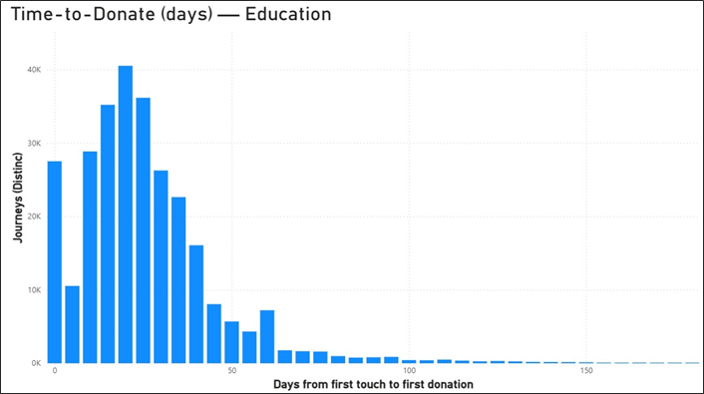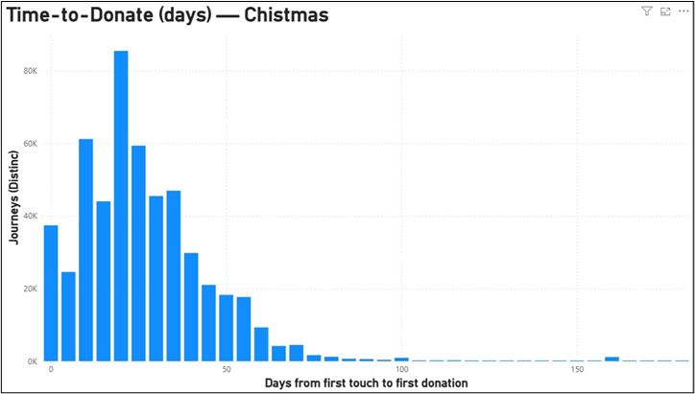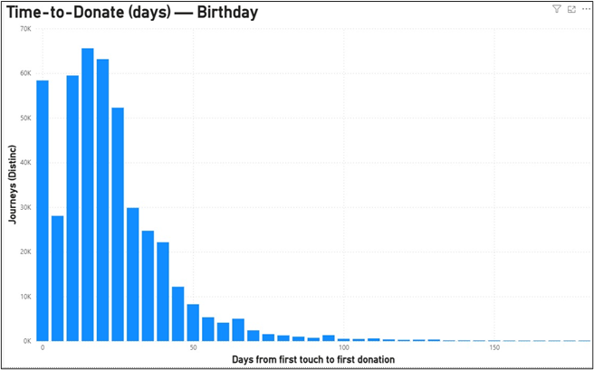
Figure 2: Time to Donate (Days)- Education Figure 3: Time to Donate (Days)- Christmas Figure 4: Time to Donate (Days)- Birthday

- Birthday = fast: Donations cluster in ~10–20 days and thin rapidly after ~40 days → a short, front-loaded sequence (DM/SMS early, brief email follow-up) fits best; long uniform journeys add needless touches.
- Christmas = slower: Distribution shifts right (~20–40 days) with a longer tail → requires more gradual persuasion; pull key value proof earlier but keep a slightly longer nurture than Birthday.
- Education = early-or-never: Peak around ~15–30 days with fewer late conversions → concentrate the strongest asks in the first two touches and gate later touches to those showing engagement.

Link to the problem: A uniform journey ignores these timing differences, causing delays for fast segments (Birthday) and wasted late touches (Education), while mis-sequencing Christmas. Segment journeys by speed and re-order channels (not reduce total touches) to cut delay and avoid over-communication.

External Data

Donations flat once you exclude one mega-gift; revenue up but uneven. The ACNC’s latest sector census shows record charity revenue of $222B (+10.7%), yet the apparent jump in donations/bequests to $18.9B was almost entirely due to a single $4.9B gift; excluding it, donations rose <0.4%. Donations are highly concentrated: ~40% went to just the top 30 charities. Smaller charities rely more on donations, but fewer received donations than the prior year (ACNC 2025). Why it matters: a thinner mass-donor pool plus concentration pressure argues for value-tiering and speed/channel segmentation to protect ROI.

DIAGNOSTIC ANALYSIS

To explore the issues within WVA’s Bounceback campaigns, we structured our analysis around the four above-mentioned diagnostic questions. These allow us to move beyond surface-level observations and uncover the underlying causes of delayed donations, uneven donor value, and inefficient communication.

Diagnostic Question 1: Are there distinct donor groups based on time-to-donation?
Figure 6: FY24 Time-to-Donation by Campaign
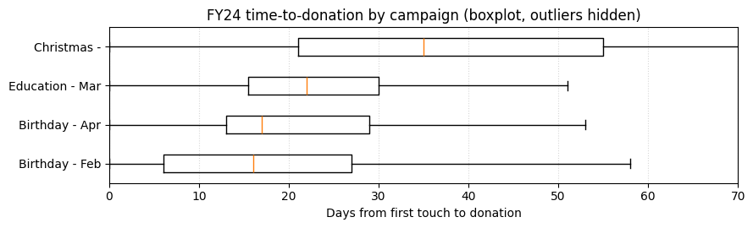
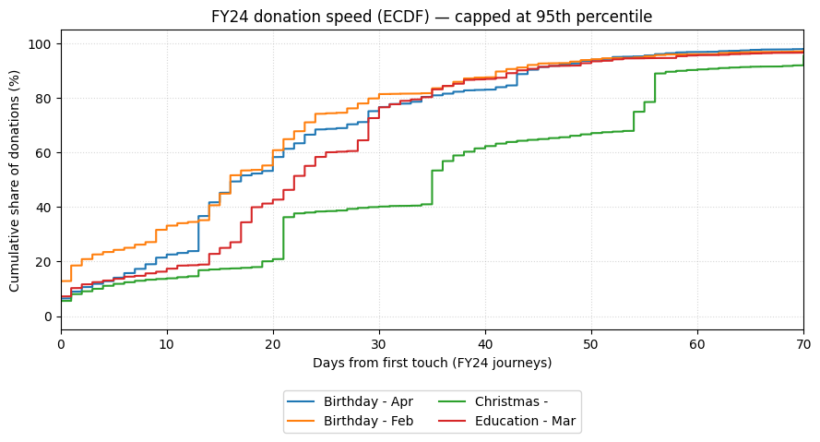
Figure 5: FY24 Donation Speed (ECDF)

Understanding when donors are most likely to give is important for WVA because it influences both revenue timing and the efficiency of supporter journeys. If different campaigns drive donations at different speeds, then treating all supporters in the same way risks either delaying income or over-nurturing donors who were ready to give sooner.

To explore this, we analysed FY24 journeys (first touch between July 2023 – June 2024) and measured the number of days from first touch to first donation. Donors were grouped into four categories: Early (≤30 days), Medium (31-60 days), Late (61-90 days), and Very Late (>90 days). This allowed us to compare typical response speeds across the three focus campaigns – Birthday, Christmas, and Education.
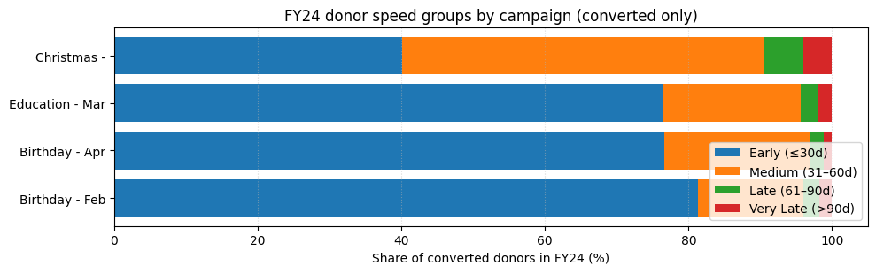

Figure 7: FY24 donor speed groups by campaign

The analysis showed clear differences:

- Birthday: Concentrated early conversion profile. The distribution is dominated by the ≤30-day segment, with steep early cumulative curves and the lowest median time-to-donation.
- Christmas: More gradual conversion profile. The mass sits in 31–60 days with a longer tail; medians are higher and the spread is wider.
- Education: Polarised pattern—converters skew early, but a large share does not convert within the journey window, yielding a high non-conversion proportion.

These findings indicate that donor timing is not uniform across campaigns. Birthday campaigns generate quick wins, Christmas drives revenue but on a longer cycle, and Education struggles with low overall conversion despite some early donors.

Diagnostic question 2: How does channel responsiveness differ across donor groups?

A central question in our analysis was whether different communication channels influence donor responsiveness at different stages of the journey. This matters for WVA because channels vary not only in cost but also in timing effectiveness, and inefficient use can lead to both wasted budget and supporter fatigue.

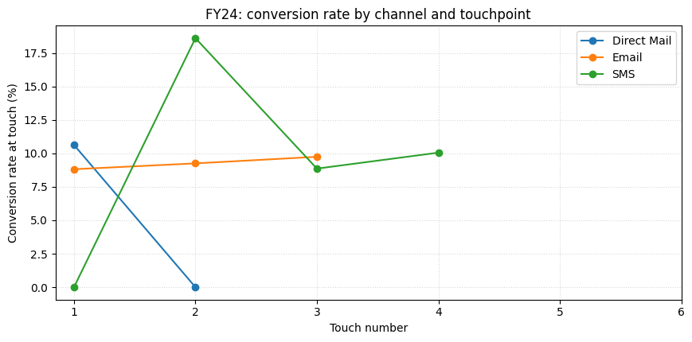

Figure 8: FY24 conversion rate by channel and touchpoint
This visual shows how donor responses are distributed across channels a different touchpoint. What stands out is that Direct Mail dominates conversions at Touch 1, indicating it works best for immediate responders. SMS peaks at Touch 2, confirming its role as an effective reminder. Email builds more slowly, with most conversions occurring from Touch 3 onwards, making it the strongest channel for nurturing over time.
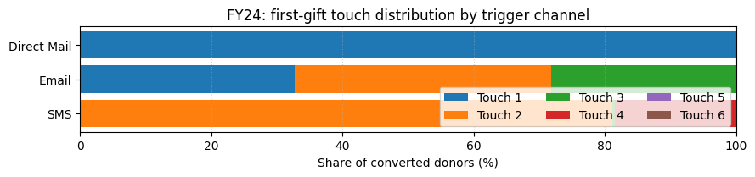

Figure 9: First gift touch distribution by trigger channel

The above graph reinforces these findings by showing when donors first respond through each channel. Almost all Direct Mail conversions occur at Touch 1, SMS peaks at Touch 2, while Email is spread across multiple touches.

Together, these insights show that channels perform at different speeds: Direct Mail is a fast-acting trigger, SMS is a strong follow-up nudge, and Email nurtures donors over time. This diagnosis points to the need for channel sequencing, where channels are not treated equally but strategically ordered to maximize early conversions and maintain engagement later.

Diagnostic Question 3: Do certain donor groups contribute more value than others?

Understanding the differences in donor values across different campaigns is critical for WVA. Currently, despite their giving behaviors, all donors receive the same treatment from WVA, which risks donor churn among high contributors and misses opportunities to accelerate donating, ultimately limiting overall contributions and campaign performance. Diagnosing value differences helps WVA to redesign the journey to reduce over-communication, shorten time to donation, and maintain or increase overall contribution levels.
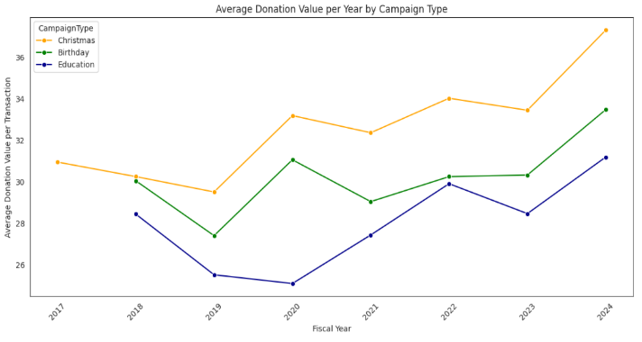
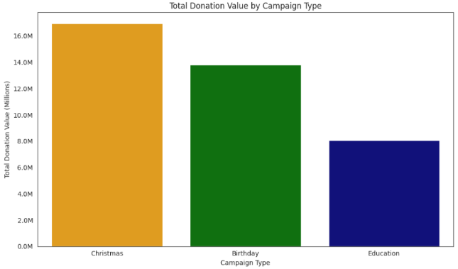
Figure 11: Average Donation Value per Year by Campaign Type
Figure 10: Total Donation Value by Campaign Type

According to Figure 10 and Figure 11,

- Christmas donors generate the highest total value (~$16M) and the highest average gift, with a strong uptick in 2024.
- Birthday donors contribute slightly less total (~$14M) but show steady growth in average gift.
- Education donors contribute the least (<$8M) and have the lowest average gift, despite gradual improvement.

Further, segmentation analysis was conducted to identify different donors based on their donation values. Percentiles are used as the threshold to segment the donors. Figures 12 and 13 below show the data related to the FY, 2024.
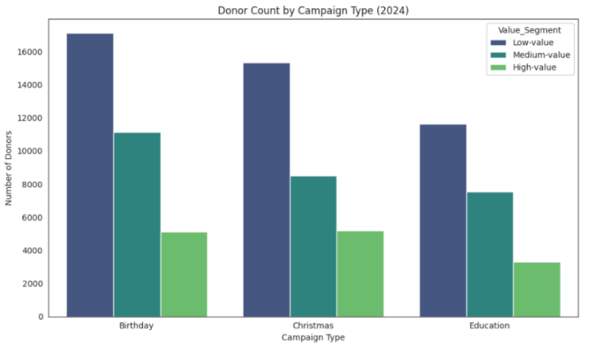
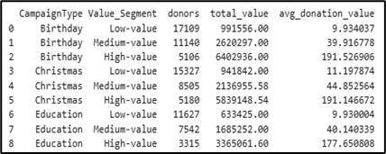

Figure 13: Value Segment by Campaign Type

Figure 12: Donor Count by Campaign Type (2024)

Referring to Figures 12 and 13, within each campaign, donor value is highly skewed:
- Low-value (≤50th percentile) donors make up about half of supporters and dominate all three campaigns.
- Medium-value (50th–80th) accounts for one-third and has potential for uplift.
- High-value (top 20%) are the fewest but financially dominant and should be protected/prioritised.

Implication: Seasonal/celebratory campaigns (Christmas/Birthday) attract higher-value giving, while Education needs targeted strategies to raise both participation and average gift; journeys should be value-tiered (protect High, uplift Medium, cost-control for Low).

Diagnostic question 4: Does engagement decay occur consistently across groups?

Here, we explore whether engagement decay occurs consistently across groups. This relates to WVA’s challenge of over-communication and delayed donations, as donors may stop responding after a certain number of touchpoints. By analyzing where engagement drops off for different campaigns, we can determine the optimal point to conclude or adjust journeys, reducing wasted effort and improving time-to-donation.

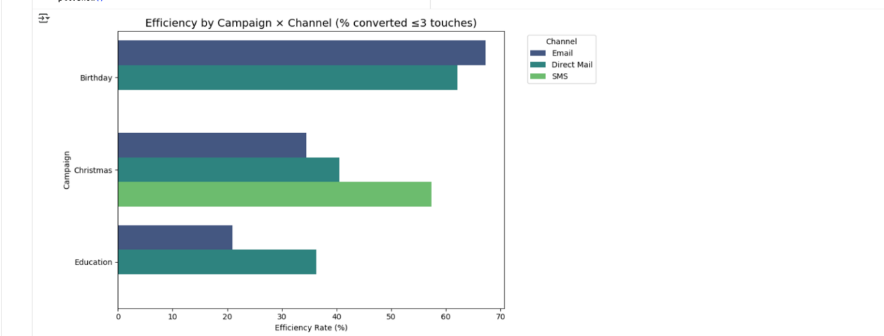
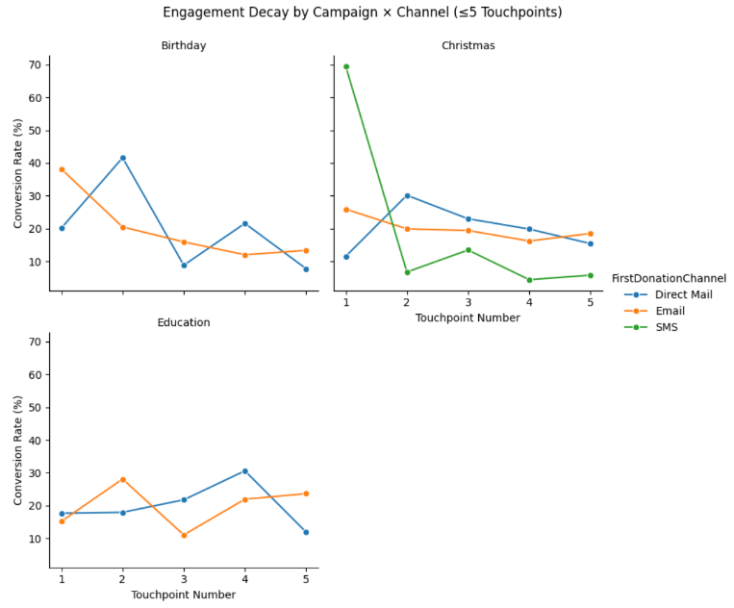
Figure 15: Efficiency by Campaign and Channel
Figure 14: Engagement Decay by Campaign and Channel
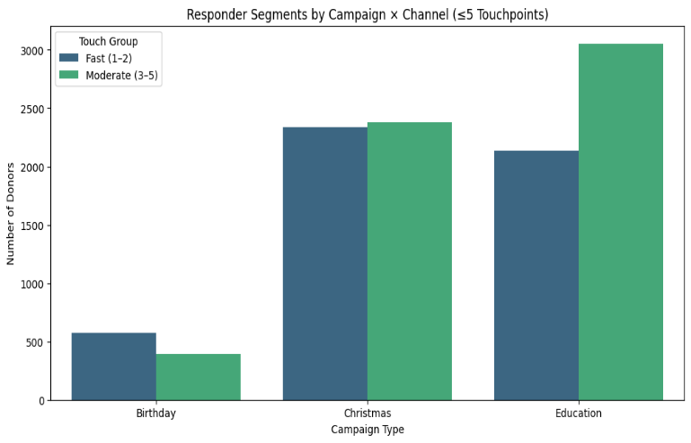
- Not consistent: Decay patterns differ clearly by campaign family.
- Birthday: Strong early conversion (Email & Direct Mail) with a sharp drop after 2 touches; dominated by fast responders (1–2 touches).
- Christmas: SMS spikes at Touch-1 then falls quickly; conversions continue into early touches but decay rapidly thereafter (quick→moderate responders).
- Education: Flatter, slower curve with conversions spread across 3–5 touches; overall lower efficiency and longer decision time.
- Efficiency within ≤3 touches: Birthday ~71–75%, Christmas ~65–90% (SMS ≈ 89.7%), Education ~54–57%.
Figure 16: Responder Segments by Campaign and Channel

Implication:
• Engagement decay differs: Birthday → fast responders, Christmas → short burst (SMS strong), Education → slower and weaker.
• A uniform journey misaligns with donor behaviors, wasting resources.
• Segmentation by campaign type and channel responsiveness is essential.
• Cap touches where decay sets in; extend only where value remains.

INTERPRETATION

From our analysis, we can see that donor behaviour is not uniform across campaigns. Birthday donors respond the quickest, Christmas donors take longer but generate strong value, and Education donors convert the least.
We also noticed that different channels work at different stages – Direct Mail is effective early, SMS acts as a reminder, and Email sustains engagement over time. On top of this, engagement does not decay in the same way across campaigns, which explains why a single journey structure doesn’t work equally well for everyone.

What stood out to us is how much variation exists between campaigns. The contrast between fast-converting Birthday donors and slower. Lower-value Education donors were sharper than we thought. This highlighted why the current uniform approach leads to over-communication in some places and missed opportunities in others.

Overall, these insights show that WVA could improve donation and donor retention by tailoring journeys and sequencing channels based on how supporters respond, rather than applying one fixed model.

RECOMMENDATIONS

RECOMMENDATION 1: OPTIMISE CHANNEL SEQUENCING

The diagnostic analysis showed that communication channels perform at different speeds. Direct Mail generates the fastest responses at the first touch, SMS is most effective as a reminder at the second touch, and Email sustains engagement over multiple touches but takes longer to convert.

We recommend that WVA adopt a sequenced approach to channels, playing to their strengths. Start with Direct Mail or SMS to capture quick responders, then follow up with Email to nurture slower but valuable conversions. Importantly, once a donor’s preferred channel is identified (e.g., Direct Mail responders or Email nurtured donors), future communications should prioritize that channel to build consistency and trust.

This sequencing optimizes early revenue generation and supports long-term conversion potential, while reducing inefficiencies by aligning each supporter with the communication style to which they are most responsive. Over time, this approach can increase donor satisfaction and retention while delivering stronger outcomes for the campaigns.

RECOMMENDATION 02: DONOR VALUE SEGMENTATION DASHBOARD

Purpose: Replace the current journey with a live dashboard that classifies supporters and campaigns into High / Medium / Low value bands and overlays speed-to-donation (≤30 / 31–60 / 61–90 / >90 days) and first-gift trigger channel (DM / SMS / Email). Keep total touches constant; optimize ordering and channel emphasis by value and speed to reduce delays and stabilize ROI.

What it delivers.
- Campaign view (Christmas / Birthday / Education): total revenue, median/mean value per donor, value-mix (100% stacked), ≤30-day conversion and median TTD.
- Action view (supporter × campaign): band assignment + recommended sequence (e.g., DM→SMS for fast responders; Email-led for nurture) with no change to touch count.
- Channel tiles: first-gift triggers and conversion by touch (T1–T4+) to front-load the most effective channel for each segment.

Why is this expected to work?
- SMS drives immediate visibility and meaningful response (nonprofit fundraising SMS response ≈ 0.14%; evening deliveries show higher conversion), supporting early-touch nudges for fast or undecided segments (M+R Benchmarks; MissionWired & Tatango).
- Direct Mail reliably outperforms email on response and often on gift value, justifying DM emphasis for High-value bands while using email/SMS for Medium/Low to protect CPDR (ANA/DMA Response Rate Report).

Quantified targets (first 2 waves, by family & band).
- ≤30-day conversion: +5–8 pp (Education); +2–3 pp (Birthday, Christmas) via earlier channel sequencing.
- Median TTD: –10 days (Education); –3 to –5 days (Birthday, Christmas).
- CPDR: –8–12% improvement in Low/Medium bands by shifting DM→SMS/Email while holding revenue.
- Average gift (High band): +10–15% by pairing early DM with timed SMS reinforcement.

Measurement & governance.
- Refresh after each wave; gate every campaign launch with a dashboard check.
- Report Day-30 / Day-60 outcomes for the four KPIs above; promote variants meeting ≥+2 pp conversion or ≥8% CPDR improvement, with no reduction in touch count.

References (APA7)

- ANA (Association of National Advertisers). (2024, February 22). ANA Response Rate Report, 2023. https://www.ana.net/miccontent/show/id/rr-2024-02-ana-response-rate-report-2023 ana.net
- Discover Publications. (2024, February 16). The 2024 direct mail report (summary of ANA/DMA 2023 results). https://discoverpubs.com/wp-content/uploads/2024/02/Direct-Mail-Report-2024.pdf Discover Publications
- M+R. (2025). Mobile messaging (M+R Benchmarks 2025). https://mrbenchmarks.com/charts/mobile-messaging M+R Benchmarks 2025
- MissionWired, & Tatango. (2024). Nonprofit text messaging insights report 2024. https://info.missionwired.com/hubfs/Nonprofit%20Text%20Messaging%20Insights%20Report%202024.pdf info.missionwired.com
- ACNC (2025). Australian Charities Report 11th Edition. https://www.acnc.gov.au/sites/default/files/documents/2025-06/ACNC%20Australian%20Charities%20Report%20-%2011th%20edition.pdf

